CSA STAR: The Future of Cloud Trust and Assurance

CSA STAR is the industry’s most powerful program for security assurance in the cloud. STAR encompasses key principles of transparency, rigorous auditing, and harmonization of standards. STAR certification provides [multiple benefits](https://cloudsecurityalliance.org/star/#_why), including indications of best practices and validation of security posture of cloud offerings.

STAR consists of three levels of assurance, which currently cover four unique offerings all based upon a succinct yet comprehensive list of cloud-centric control objectives in the CSA’s [Cloud Controls Matrix (CCM)](https://cloudsecurityalliance.org/group/cloud-controls-matrix/). CCM is the only meta-framework of cloud-specific security controls, mapped to leading standards, best practices and regulations. CCM provides organizations with the needed structure, detail and clarity relating to information security tailored to cloud computing.

The STAR program includes a [complimentary registry](https://cloudsecurityalliance.org/star/#_registry) that documents the security controls provided by popular cloud computing offerings. This publicly accessible registry is designed for users of cloud services to assess their cloud providers, security providers and advisory and assessment services firms in order to make the best procurement decisions.

CSA STAR is based upon two key research components of the CSA GRC Stack:

**Cloud Controls Matrix (CCM)** - As a controls framework, the CSA CCM provides organizations with the needed structure, detail and clarity relating to information security tailored to cloud computing.

<https://cloudsecurityalliance.org/research/ccm/>

**The Consensus Assessments Initiative Questionnaire (CAIQ)** - Based upon the CCM , the CAIQ provides a set of Yes/No questions a cloud consumer and cloud auditor may wish to ask of a cloud provider to ascertain their compliance to the Cloud Controls Matrix and CSA best practices.

<https://cloudsecurityalliance.org/group/consensus-assessments/>

CSA STAR PROGRAM ASSESSMENT AND CERTIFICATIONS

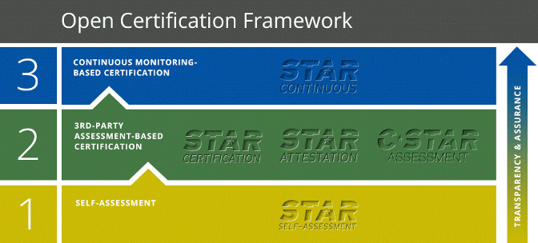

LEVEL ONE: CSA STAR Self-Assessment

CSA STAR Self-Assessment is a complimentary offering that documents the security controls provided by various cloud computing offerings, thereby helping users assess the security of cloud providers they currently use or are considering using. Cloud providers either submit a completed The Consensus Assessments Initiative Questionnaire (CAIQ), or to submit a report documenting compliance with Cloud Controls Matrix (CCM). This information then becomes publicly available, promoting industry transparency and providing customer visibility into specific provider security practices.

<https://cloudsecurityalliance.org/star/self-assessment/>

LEVEL TWO: CSA STAR Attestation

CSA STAR Attestation is a collaboration between CSA and the AICPA to provide guidelines for CPAs to conduct SOC 2 engagements using criteria from the AICPA (Trust Service Principles, AT 101) and the CSA Cloud Controls Matrix. STAR Attestation provides for rigorous third party independent assessments of cloud providers.

<https://cloudsecurityalliance.org/star/attestation/>

LEVEL TWO: CSA STAR Certification

The CSA STAR Certification is a rigorous third-party independent assessment of the security of a cloud service provider. The technology-neutral certification leverages the requirements of the ISO/IEC 27001:2005 management system standard together with the CSA Cloud Controls Matrix.

<https://cloudsecurityalliance.org/star/certification/>

LEVEL TWO: CSA C-STAR Assessment

The CSA C-STAR Assessment is a robust third party independent assessment of the security of a cloud service provider for the Greater China market that harmonizes CSA best practices with Chinese national standards. C-STAR leverages the requirements of the GB/T 22080-2008 management system standard together with the CSA Cloud Controls Matrix, plus 29 related controls selected from GB/T 22239-2008 and GB/Z 28828-2012.

<https://cloudsecurityalliance.org/star/c-star/>

LEVEL THREE: CSA STAR Continuous Monitoring

Currently under development, CSA STAR Continuous Monitoring enables automation of the current security practices of cloud providers. Providers publish their security practices according to CSA formatting and specifications, and customers and tool vendors can retrieve and present this information in a variety of contexts.

<https://cloudsecurityalliance.org/star/continuous/>